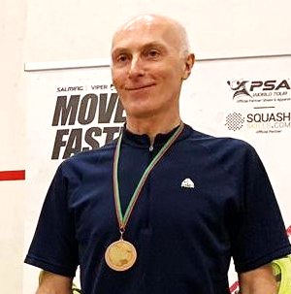
Coolhurst 2020 AGM
Nominee for Treasurer : Paul Harris
Proposer : Dave Smart
Seconder : Mike Creaven

Personal Statement
________________________________________________________________________________
The motivation in renewing my nomination for the role of Treasurer is driven by major concern over the Club’s financial standing. Our tenant status means that the Club has no significant, realisable assets. We are servicing over £0.5 million of long-term debt which as a result constrains funding for capital projects and costs for unforeseen repairs.
As nominee, I am confident with interpreting the financial performance of major organisations. In business I operated with executive responsibility for large budgets and was judged in my role for the successful delivery of time critical, capital projects.
I currently act as treasurer and trustee for a Highgate Charity which runs a unique contractual arrangement with Camden Council; also, as director and treasurer of a Community Trust in Scotland which generates income to support local sports and arts groups. My own company directly supports local community projects in my home village in Scotland.
I am determined and passionate in what I take on; qualities I hope that have earned me the honour of captaining Scotland as a masters squash player. Since retiring from full time work, I can offer my time and energy voluntarily. As a member of the GMC led by prospective Chairman Steve Nardelli, the objective must be to deliver improvements for everyone at the Club. My immediate focus if elected as Coolhurst’s Treasurer will be:
- to establish transparency over the financial health of the Club
- to separate the roles of Accountant and Treasurer, whilst retaining independent scrutiny by an external audit
- to prioritise reduction of debt
- to ensure the Club runs efficiently
- to focus investment in the Club’s sporting and social facilities, based on Members’ input

Ultimately, our Club should provide each member, across all ages and abilities, with a consistently fun and fulfilling playing experience and strive to be seen as one of the top sporting brands in the South of England.
________________________________________________________________________________

