Nominee for Tennis member: Christian Midhage 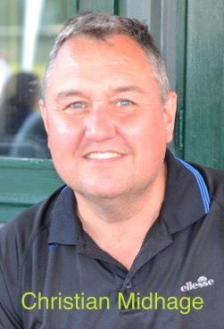
_____________________________________________________________________________ Personal Statement
I’ve played tennis at Coolhurst, as a child, as an adult, and I still play most days. I have been a previous member of the GMC, and later filled the position of tennis secretary. I do genuinely love this club, and play an active role in its welfare and its future.
If elected I would push for:
- A more aggressive attempt to reduce the club’s debt, so that our facilities can be better funded in the future.
- Transparent governance and financial reporting by GMC members.
- A more broadly representative tennis committee

For these reasons, I am recommending Paul Harris for the role of Treasurer, and Steve Nardelli as Chairman. I want the future for Coolhurst to have the best facilities for its members to benefit from.
I look forward to your vote onto the GMC as a tennis member.

Christian Midhage

