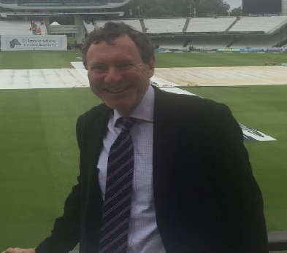
Charlie Logan Personal Statement

I am the incumbent Squash Secretary having stepped up when Giles moved out of London last summer. I would like to carry on so I can continue making Coolhurst the best place to play squash for all its members.
We have made good progress by investing in facilities, events and coaching, whilst being mindful of our financial responsibilities to the club as a whole. As the audited accounts show squash has made a substantial surplus on its activities, increasing over the year from £103,900 in 2018 to £117,200 last year, whilst our membership has held firm.
For 2020/21 I would look to lead on the following initiatives;
-Continue to drive participation in the leagues and club nights by introducing innovations as we have this last year.
-Courts can be further improved, we had all 7 courts renovated in 2019, as well as further LED lighting, I hope we can improve courts 3-6 through some sensitive ideas to improve what is a great space.
-Teams have been good this year, we have the most teams and team registered players in Middlesex. All our teams have competed strongly in their divisions and Coolhurst remains one of the most popular hosting clubs. But there are some ways we could involve an even greater cross section of members.
-Club tournaments have had record entries so I will ensure they remain well run and attractive to all. We will commence the 2020 club championships on 13/4 starting with the doubles and finishing on finals night 15/5. The junior tournament will once again run concurrently with the Gareth Pugh handicap in November, an innovation which worked well in 2019.
-Events including the PSL and ES tournaments have all at least covered their costs. Next year we would like to explore the possibility of a Challenger event on the PSA, as a replacement to the PSL, when the options have been reviewed we will put to the members for their preference.
-Coaching is now making a small surplus and this year we would continue to diversify the coaching offering as we have with initiatives such as beginner classes and drop in sessions for intermediate players at club night.
- I will continue the monthly squash update whilst continuing to be an active and accessible member around the club, ensuring all members can have an input into how squash is run.
As squash Secretary I would endeavour to involve a cross section of members interests so that Coolhurst encourages more people, to play more squash, more often.
Charlie.
Charles Logan
07785 731226

